THANKSGIVING PROJECT 2016 FOR ALL STUDENTS & CLASSES
“TURKEYS AGAINST BULLIES”
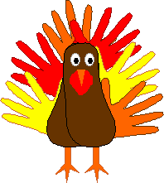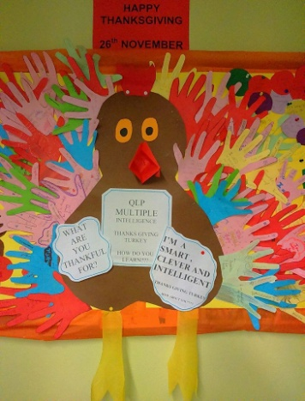
THIS YEAR USE ONLY YELLOW PAPER for the feathers so it is in line with the Keep Smiling theme.
This project will focus on support networks and help every student realize their support network. The feathers are made up of hand cut-outs on YELLOW paper. The student writes one name on each finger of the hand below. It could be a family member, teacher, friend, sibling, relative, animal etc. they would turn to if they needed support. On the palm area they write their own name and group. Use hashtags #KeepSmiling #KeepSmilingWithQLS #QLSThanksGiving #TurkeysVSBullies on social media posts.
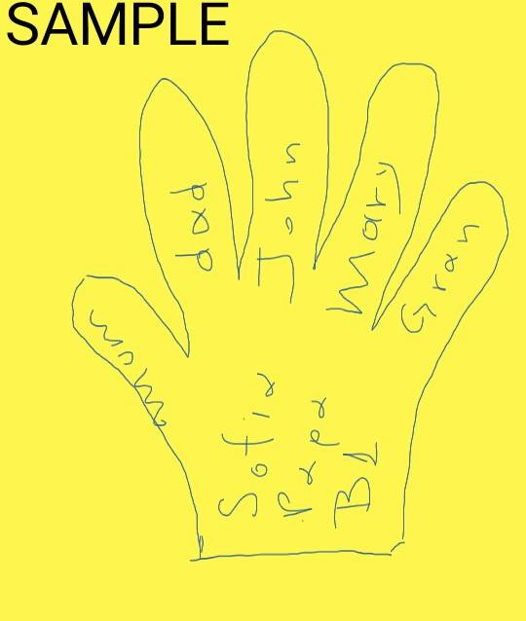

HAND CUT-OUT TEMPLATE
